



* You may question what you are doing. Just go with it.
* You may get really dirty, like paint everywhere dirty. Just go with it.
* You may wonder why you destroyed this perfect book. Just go with it.
* You may begin destructive creativity. This can be good.
* You may begin to live more recklessly. Not sure if this is good. Just go with it for now.

During the process of this book,

the follow things may happen:



1. Doodle on every single page of this book
2. Follow the instructions on every page
3. Order is not important
4. Instructions are open to interpretation
5. Experiment
6. Have fun

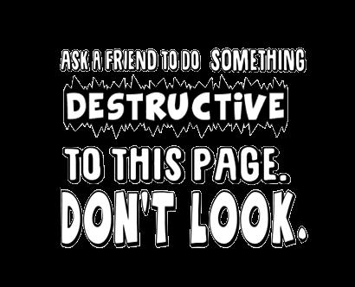

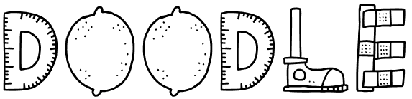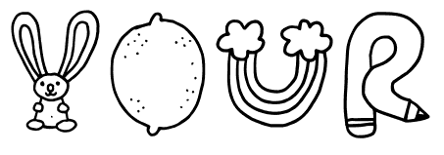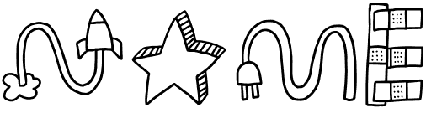

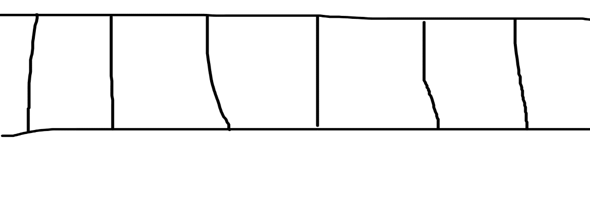

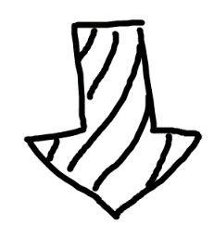

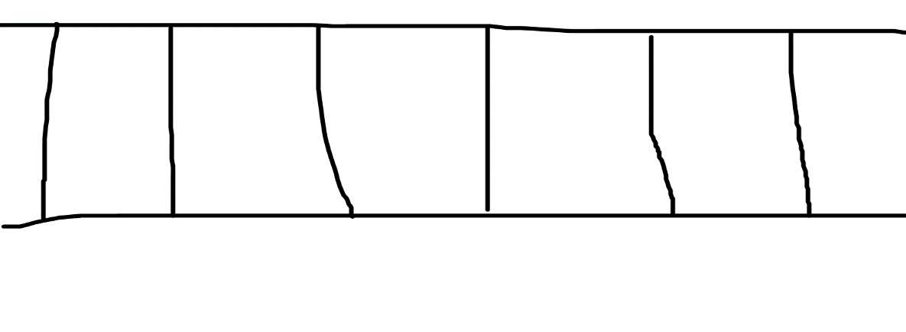

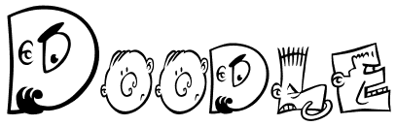

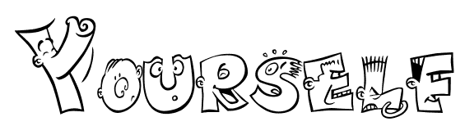





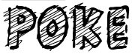

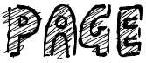

[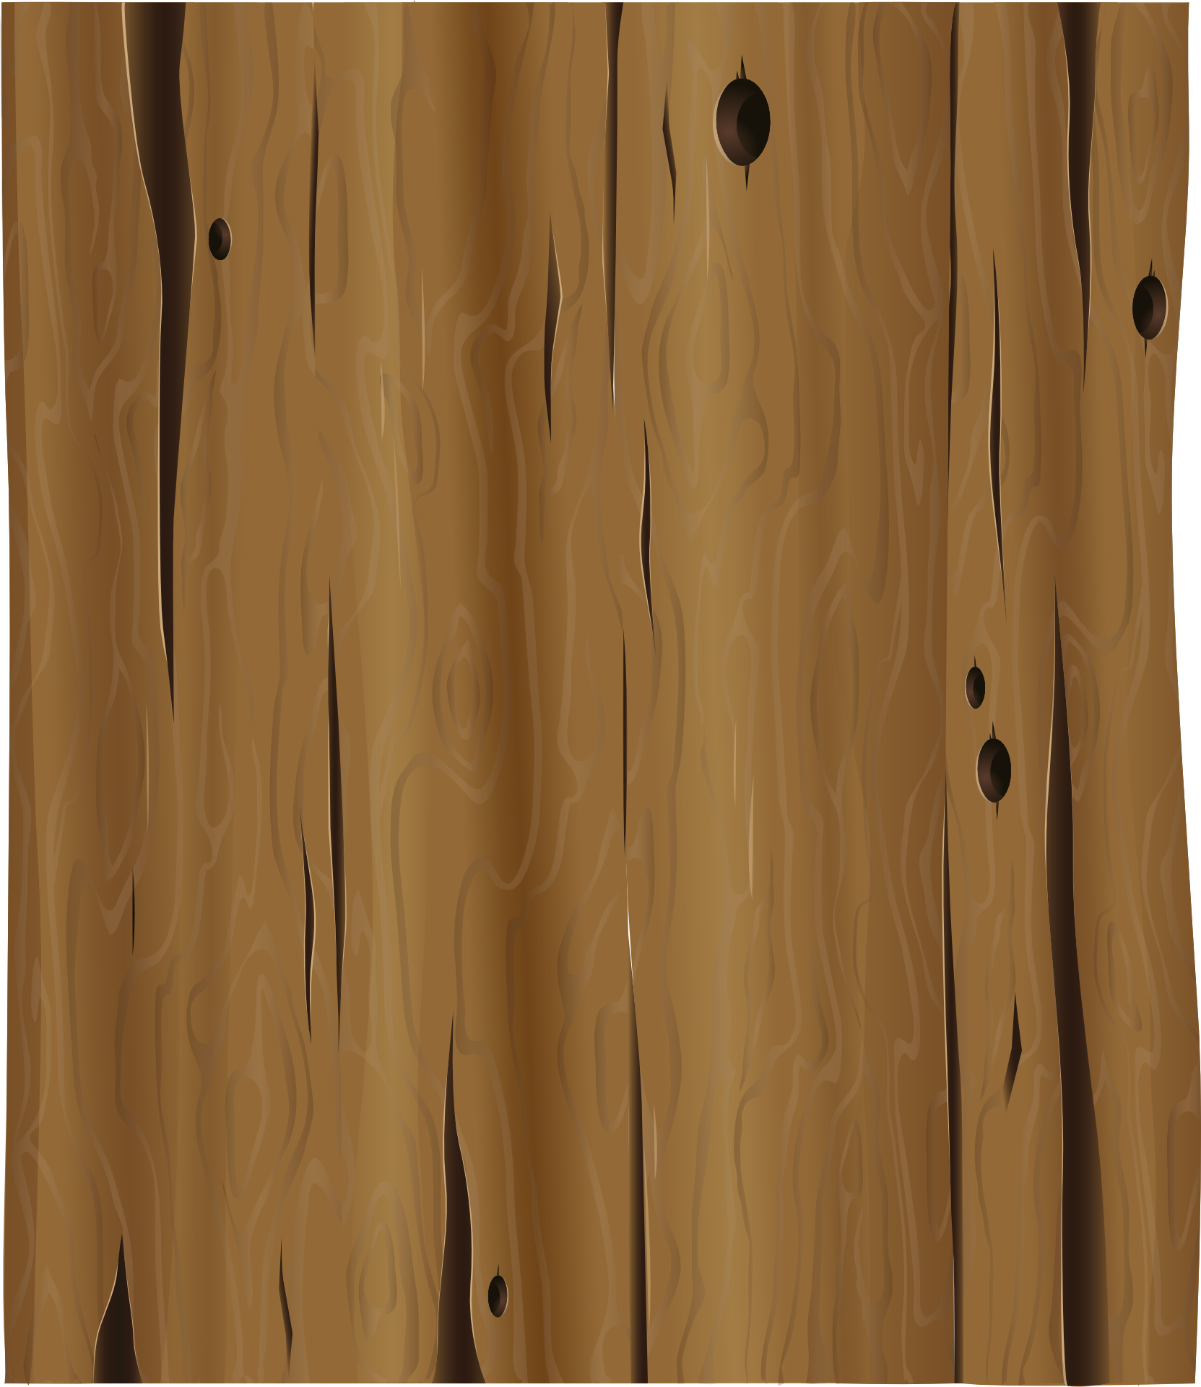](https://www.google.com/url?sa=i&rct=j&q=&esrc=s&source=images&cd=&ved=2ahUKEwjWnNm3oprnAhUNbc0KHVHACf0QjRx6BAgBEAQ&url=https%3A%2F%2Fpixy.org%2F203808%2F&psig=AOvVaw1ttAPDzQNhKbpDdwMM4ozF&ust=1579887692100525)

[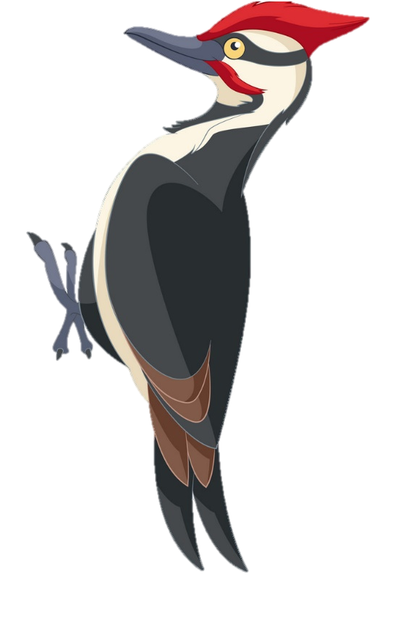](https://www.google.com/url?sa=i&rct=j&q=&esrc=s&source=images&cd=&ved=2ahUKEwiw99vgoprnAhUOa80KHbbaCnUQjRx6BAgBEAQ&url=https%3A%2F%2Fwww.vectorstock.com%2Froyalty-free-vector%2Fcartoon-smiling-woodpecker-vector-15274164&psig=AOvVaw01b9DI7tHbsE2l3qt6sn_n&ust=1579887777216539)

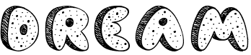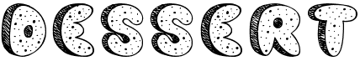

[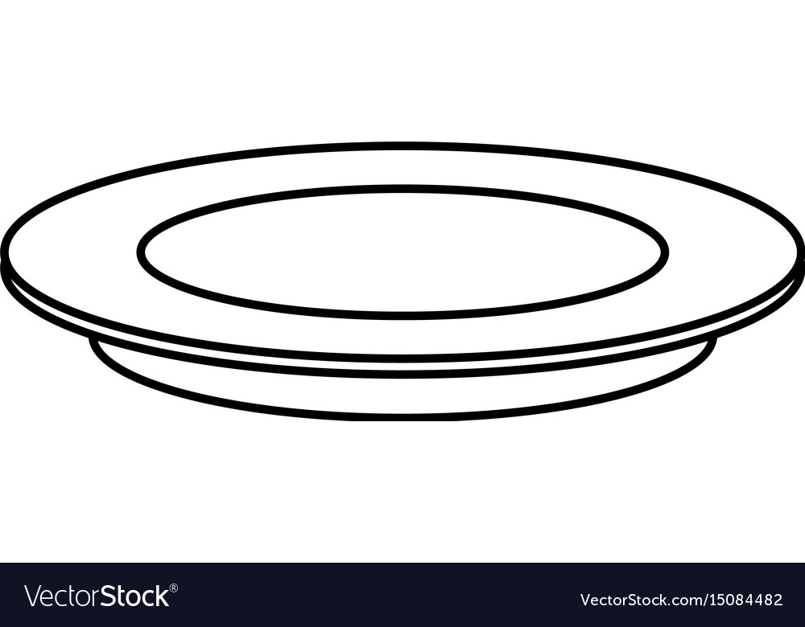](https://www.google.com/url?sa=i&rct=j&q=&esrc=s&source=images&cd=&ved=2ahUKEwjS4cb59JnnAhVwB50JHfM7C0sQjRx6BAgBEAQ&url=https%3A%2F%2Fwww.vectorstock.com%2Froyalty-free-vector%2Foutline-plate-dish-empty-round-icon-vector-15084482&psig=AOvVaw2tJhXdJo6d5cKKkiDJyaf7&ust=1579875482726164)

**Colour the boxes without the same colours touching**



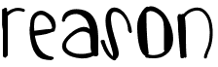

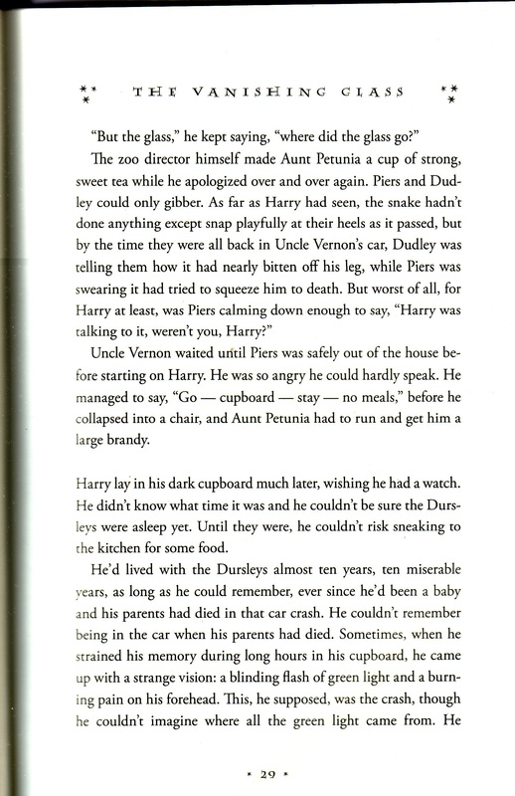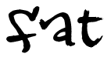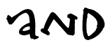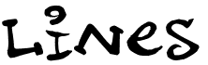











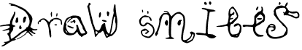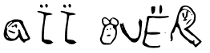

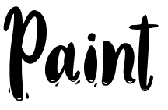

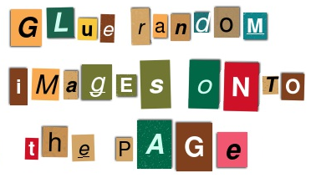

[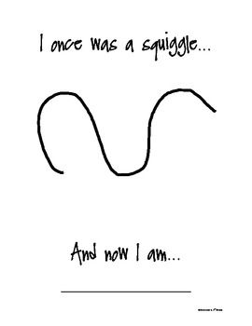](https://www.google.com/url?sa=i&rct=j&q=&esrc=s&source=images&cd=&ved=2ahUKEwjj6eur8ZznAhUPQ80KHaW4DcIQjRx6BAgBEAQ&url=https%3A%2F%2Fwww.pinterest.com%2Fpin%2F384987468126789866%2F&psig=AOvVaw1O8xyUo0BuPhKzpcPtN7HV&ust=1579977526299489)

[](https://www.google.com/url?sa=i&rct=j&q=&esrc=s&source=images&cd=&ved=2ahUKEwjj6eur8ZznAhUPQ80KHaW4DcIQjRx6BAgBEAQ&url=https%3A%2F%2Fwww.pinterest.com%2Fpin%2F384987468126789866%2F&psig=AOvVaw1O8xyUo0BuPhKzpcPtN7HV&ust=1579977526299489)









